North East and North Cumbria ICB
Pemberton House
Sunderland

25th July 2025

Dear Colleague

Changes to delivery model of treatment for community-based patients with Covid-19 in North East and North Cumbria ICB.

In December 2020, at the height of the pandemic, NHS England commissioned Covid
Medicines Delivery Units to conduct the roll out of novel antiviral and neutralising monoclonal antibody treatments for patients with Covid-19 who are at risk of serious illness and hospitalisation.

Since that time, North East and North Cumbria ICB have commissioned a provider to deliver a service comprising of the assessment of eligible non-hospitalised patients and prescribing of treatments for Covid-19.

From 1st August this service will be provided by community pharmacies as part of the NHS Community Pharmacy Independent Prescribing Pathfinder Programme.

Pharmacists will carry out remote clinical assessments of non-hospitalised patients to determine their suitability for Covid-19 treatments. If a patient qualifies, the pharmacist will prescribe the most suitable treatment and send that via EPS to the NHS Spine or a community pharmacy. The treatments are not hospital-only medicines and can be obtained and dispensed by community pharmacies.

The service provider can be contacted on ips.nenc.cmdu@nhs.net and will accept patient referrals via direct email or from NHS111. Patients can also self-refer using the same email address.

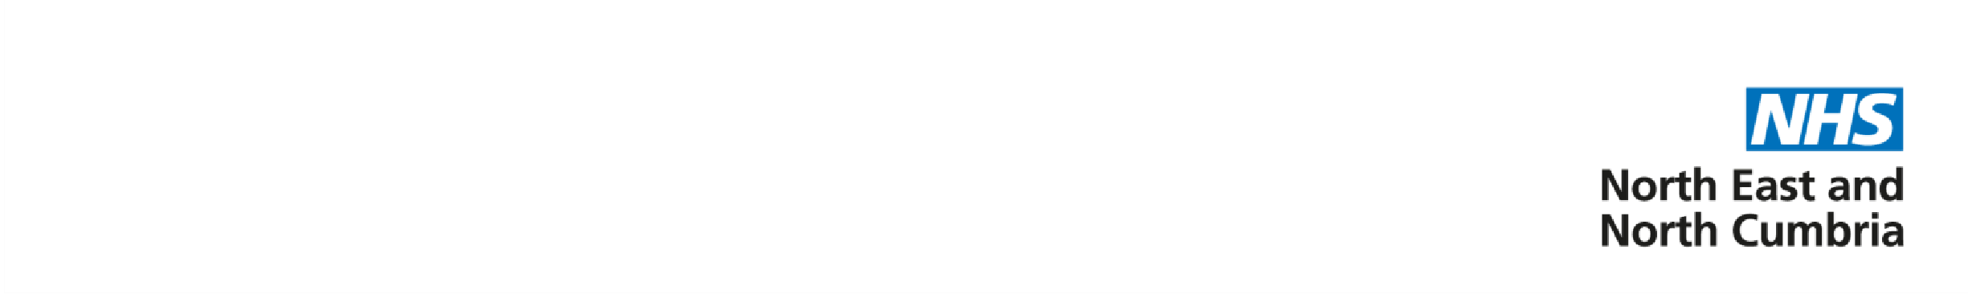
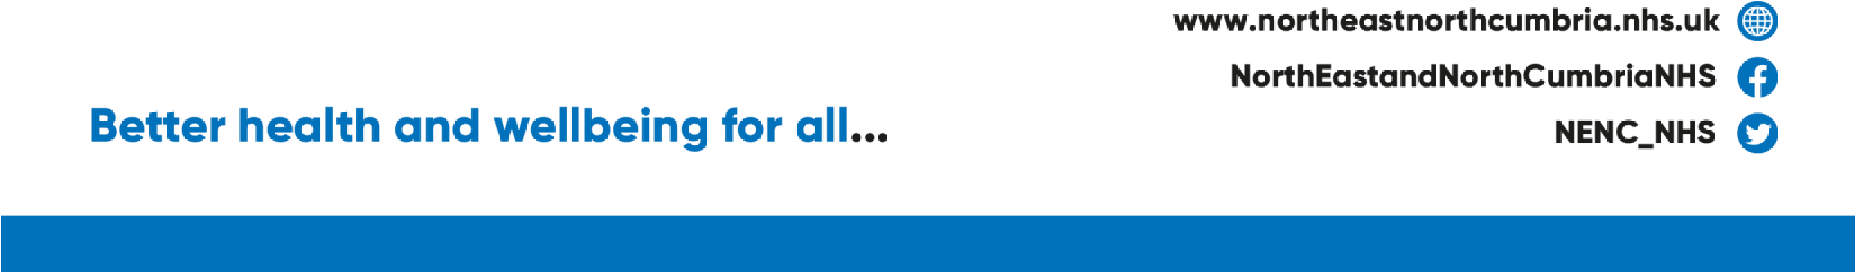
Eligible patients
The current list of eligible patient cohorts is available here. This has not changed.

Patients being referred must:
- be at high risk of getting seriously ill from COVID-19 (i.e. in one of the cohorts defined above)
- have COVID-19 symptoms
- have tested positive for COVID-19
- be within 5 days of both testing positive and the start of the symptoms
- be over 18 years of age

Paediatrics
Patients under 18 who meet the eligibility criteria should be referred to their secondary care specialist consultant.

Yours sincerely

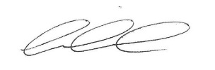

Ewan Maule
Clinical Director – Medicines and Pharmacy

